
American International University- Bangladesh (AIUB) Faculty of Engineering (FE)

Course Name: | DATA COMMUNICATION | Course Code: | COE3103
Semester: | Spring 2024-25 | Section: | L
Faculty: | DR. AMIRUL ISLAM | Group: | 08
Experiment No: | 06
Experiment Name: | Study of Digital to Analog Conversion using MATLAB

Submitted by (NAME): | MOHSIN IBNA HOSSAIN | Student ID: | 23-50194-1
Group Members |  | Name | ID
 | 1. | MD. MIRAN HOSSAIN | 22-46175-1
 | 2. | FAHMIDA RAHMAN | 22-48483-3
 | 3. | MOHSIN IBNA HOSSAIN | 23-50194-1
 | 4. | MD. YEAHYEA JAM | 23-50187-1
 | 5. | HOSSAIN MOHAMMAD SAMI | 23-51354-1

Performance Date: | 28/04/2025 | Due Date: | 05/05/2025
Marking Rubrics (to be filled by Lab Instructor)
Category | Proficient [6] | Good [4] | Acceptable [2] | Unacceptable [1] | Secured Marks
Theoretical Background, Methods & procedures sections | All information, measures and variables are provided and  explained. | All Information provided is sufficient, but more explanation is  needed. | Most information is correct, but some information may be  missing or inaccurate. | Much information is missing and/or inaccurate.
Results | All of the criteria are met; results are described clearly and accurately; | Most criteria are met, but there may be some lack of clarity and/or incorrect information. | Experimental results don’t match exactly with the theoretical values and/or analysis  is unclear. | Experimental results are missing or incorrect;
Discussion | Demonstrates thorough and sophisticated understanding.  Conclusions drawn are appropriate for  analyses; | Hypotheses are clearly stated, but some concluding statements not supported by data or data not well  integrated. | Some hypotheses missing or misstated; conclusions not supported by data. | Conclusions don’t match hypotheses, not supported by data; no integration of data from different sources.
General formatting | Title page, placement of figures and figure captions, and other  formatting issues all correct. | Minor errors in formatting. | Major errors and/or missing information. | Not proper style in text.
Writing & organization | Writing is strong and easy to understand; ideas are fully elaborated and connected; effective transitions between sentences; no  typographic, spelling, or grammatical errors. | Writing is clear and easy to understand; ideas are connected; effective transitions between sentences; minor typographic, spelling, or grammatical errors. | Most of the required criteria are met, but some lack of clarity, typographic, spelling, or grammatical errors are present. | Very unclear, many errors.
Comments: |  |  |  | Total Marks (Out of 30):

Title
Study of Digital to Analog Conversion using MATLAB
Abstract
This experiment is designed to-
1.To understand the use of MATLAB for solving communication engineering problems.
2.To develop understanding of Digital to Analog conversion using MATLAB.
Introduction
Digital to Analog Conversion is the process of transforming digital data into an analog signal by altering one of the properties of a carrier wave — typically amplitude, frequency, or phase. This is essential for sending digital data over analog communication channels such as telephone lines, radio frequencies, or optical systems.
There are several standard techniques for digital to analog conversion:
- Amplitude Shift Keying (ASK): The amplitude of the carrier signal changes with the digital bit value. A ‘1’ may be represented with full amplitude, while a ‘0’ is represented with zero or reduced amplitude. Frequency and phase remain constant.
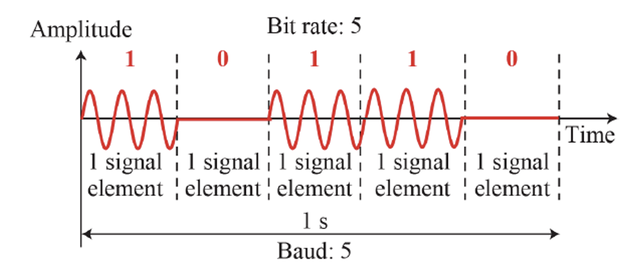
Fig1: Binary amplitude shift keying
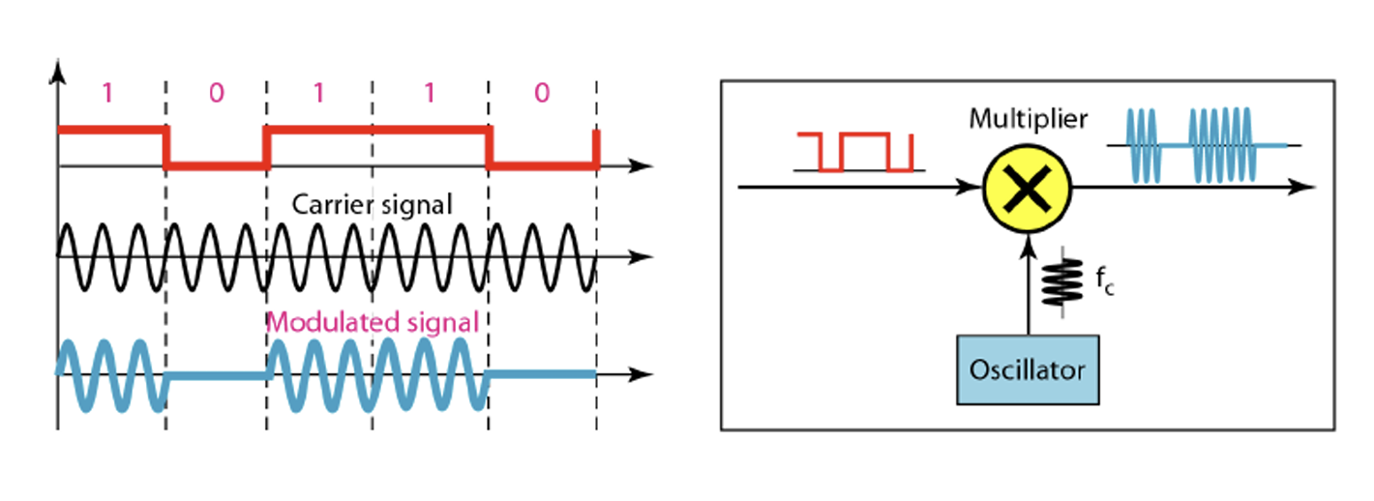
Fig2: Implementation of binary ASK
- Frequency Shift Keying (FSK): The frequency of the carrier signal is changed depending on the input bit, while the amplitude and phase remain constant.
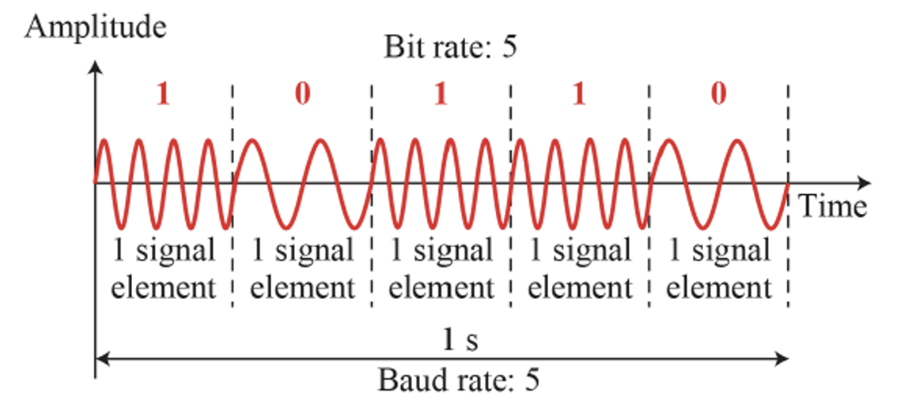
Fig3: Binary Frequency Shift Keying
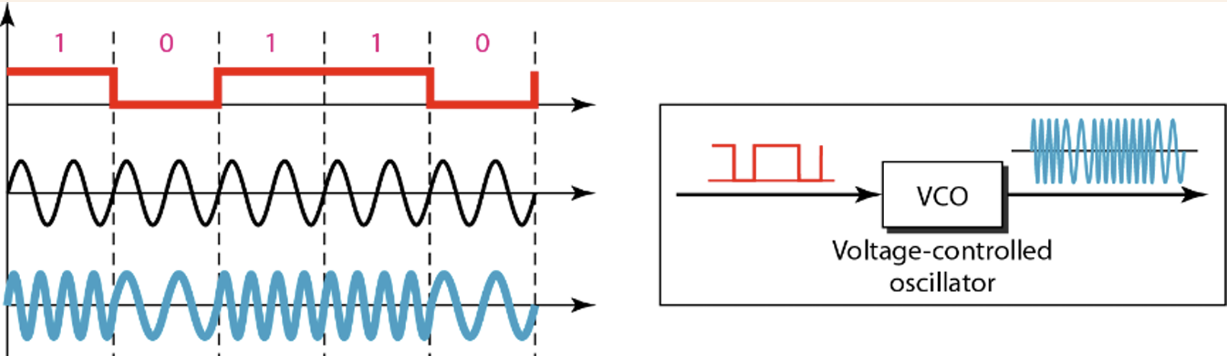
Fig4: Implementation of BFSK
- Phase Shift Keying (PSK): The phase of the carrier signal is changed to represent binary data, keeping amplitude and frequency constant. PSK is more bandwidth-efficient and noise-resilient compared to ASK and FSK.
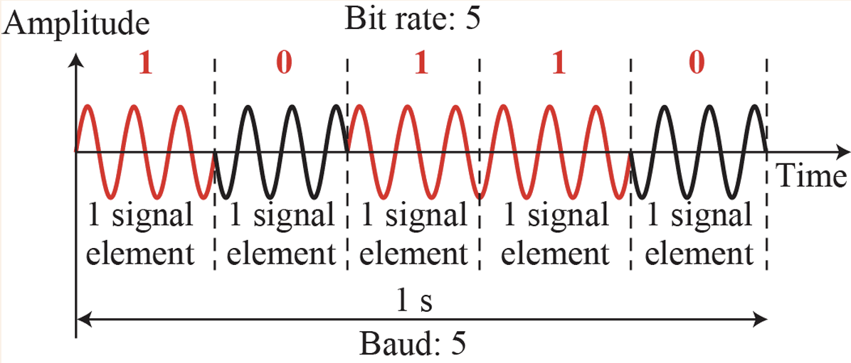
Fig5: Binary Phase Shift Keying
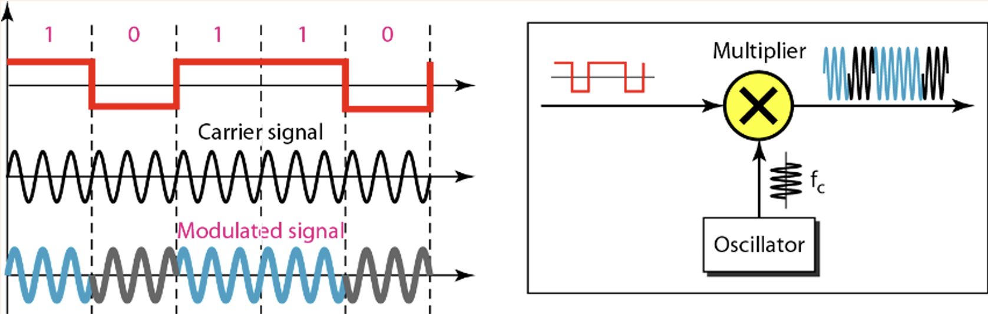
Fig6: Implementation of BPSK

- Quadrature Phase Shift Keying (QPSK): This is an extension of PSK where two bits are transmitted per symbol using four distinct phase shifts. It effectively doubles the data rate of standard BPSK without increasing bandwidth.
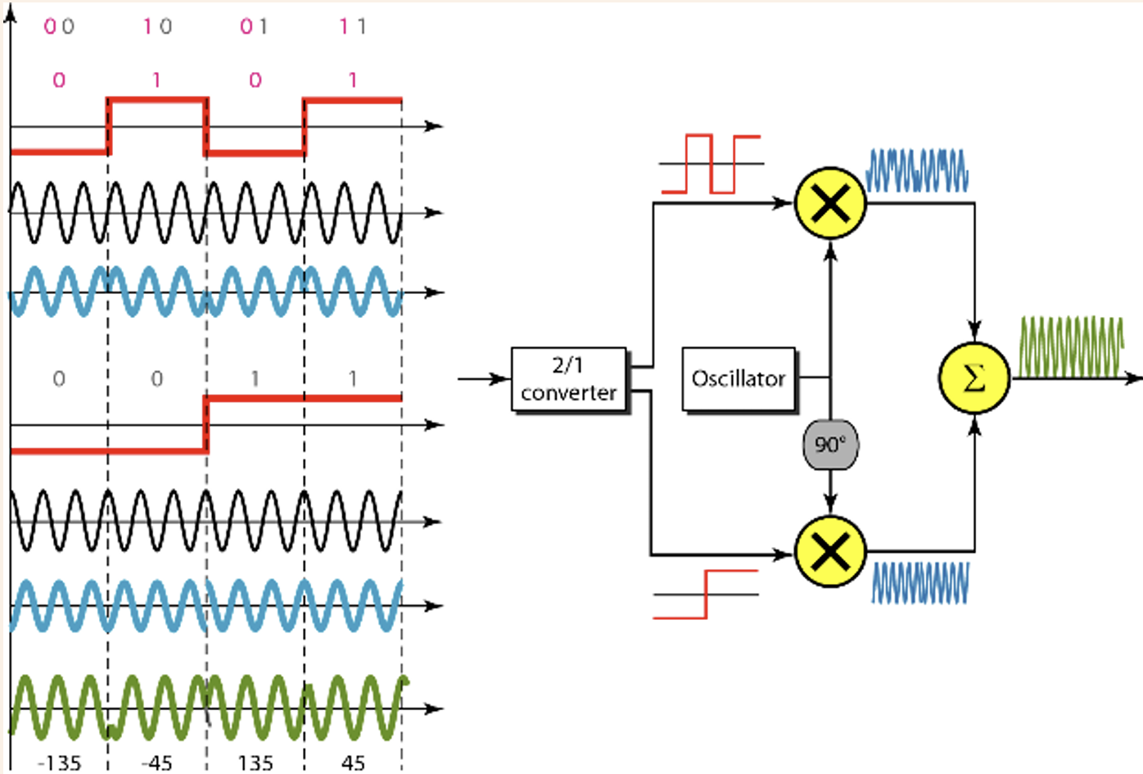
Fig7: Implementation of QPSK
Results and Discussion
1. 8-ASK: Different amplitudes for 000 to 111 in the modulated signal can be 0V, 1V, 2V, 3V, 4 V, 5 V, 6 V, and 7 V respectively.
2. 8-FSK: Different frequencies for 000 to 111 in the modulated signal can be 1Hz, 2Hz, 3Hz, 4Hz, 5 Hz, 6 Hz, 7 Hz, and 8 Hz respectively.
3. 8-PSK: Different phases for 000 to 111 in the modulated signal can be 0, pi/4, 3*pi/4, pi/2, -pi/4, -pi/2, pi, -3*pi/4 respectively.
Duration of each signal element must be 1 second.
Code:
close all;
clc;

bit_stream = [0 0 1 1 0 0 0 1 0 0 1 1 1 0 0 1 0 0 1 1 0 1 0 0];

%// Group bits manually into 3-bit groups
symbols = zeros(1,8);
k = 1;
for j = 1:3:24
b1 = bit_stream(j);
b2 = bit_stream(j+1);
b3 = bit_stream(j+2);
symbols(k) = b1*4 + b2*2 + b3*1;
k = k + 1;
end

%// Parameters
fs = 1000;
fc = 5;

amplitudes = [0 1 2 3 4 5 6 7];
frequencies = [1 2 3 4 5 6 7 8];
phases = [0 pi/4 3*pi/4 pi/2 -pi/4 -pi/2 pi -3*pi/4];

%// Define a colormap (use "jet" for colorful effect like in your figure)
colors = jet(8);
nx = 8;
i = 1
while i <= nx
t = i:0.001:i+1-0.001;
symbol = symbols(i);

A = amplitudes(symbol+1);
ask = A*sin(2*pi*fc*t);

f = frequencies(symbol+1);
fsk = sin(2*pi*f*t);

phi = phases(symbol+1);
psk = sin(2*pi*fc*t + phi);

%// Plotting with different color for each symbol
subplot(3,1,1);
plot(t,ask,'Color',colors(i,:),'LineWidth',1.5);
hold on;
grid on;
axis([1 9 -8 8]);
title('Amplitude Shift Key');

subplot(3,1,2);
plot(t,fsk,'Color',colors(i,:),'LineWidth',1.5);
hold on;
grid on;
axis([1 9 -1.5 1.5]);
title('Frequency Shift Key');

subplot(3,1,3);
plot(t,psk,'Color',colors(i,:),'LineWidth',1.5);
hold on;
grid on;
axis([1 9 -1.5 1.5]);
title('Phase Shift Key');

i = i + 1;
end

Result and Discussion:
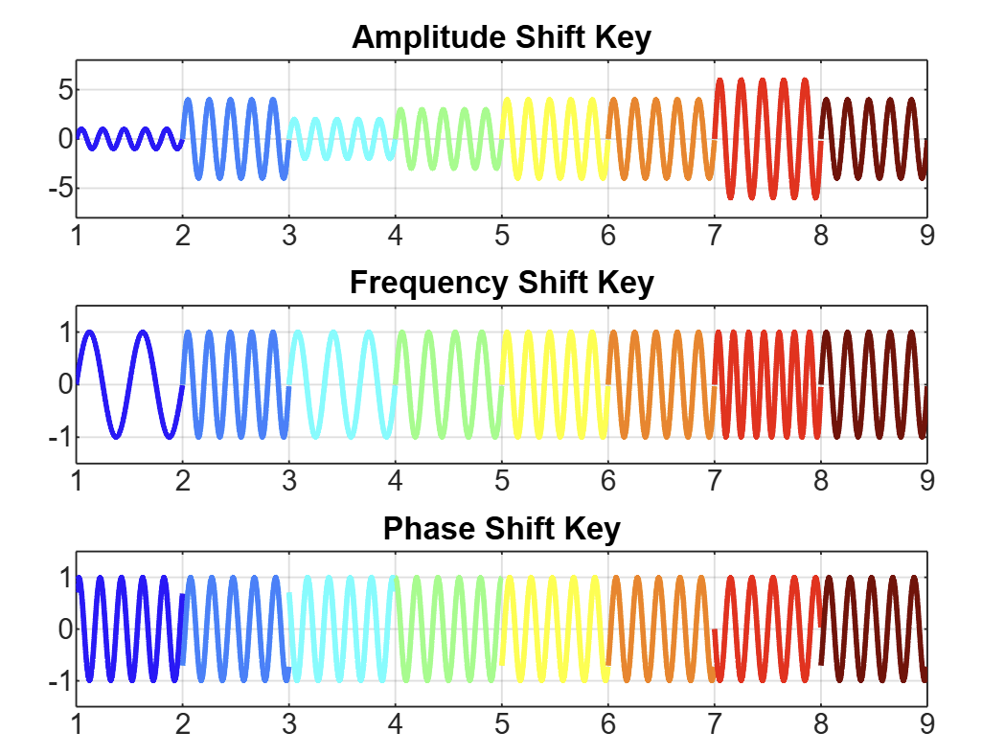
Fig8: 8-Level ASK, FSK, and PSK Signal Representations for 3-bit Digital Symbols
In this experiment, digital-to-analog conversion techniques including Amplitude Shift Keying (ASK), Frequency Shift Keying (FSK), and Phase Shift Keying (PSK) were implemented using MATLAB. The use of 3-bit symbols (000 to 111) allowed for the creation of 8 distinct signal variations per technique, corresponding to unique amplitudes, frequencies, and phases for ASK, FSK, and PSK respectively.
The simulation successfully demonstrated how these techniques represent digital data in analog form. Each modulation scheme was clearly visualized in MATLAB plots, showing the appropriate changes in waveform characteristics across time. ASK signals showed varying amplitude levels while frequency and phase remained constant. FSK signals maintained consistent amplitude and phase but differed in frequency based on symbol values. PSK signals displayed changes in phase while keeping amplitude and frequency unchanged. These visual outputs confirmed theoretical expectations and highlighted the modulation schemes’ distinct encoding approaches.
Furthermore, the code logic grouped the bit stream efficiently into symbols and applied the modulations accordingly. The color-coded representation enhanced clarity in distinguishing symbol transitions across each modulation technique.

Conclusion
This experiment successfully illustrated the principles of Digital to Analog Conversion using MATLAB. The implementation of 8-ASK, 8-FSK, and 8-PSK schemes demonstrated how digital bits can be transformed into varying analog signal forms by modifying amplitude, frequency, and phase respectively. The simulation outcomes aligned well with theoretical models, reinforcing understanding of each modulation type. Overall, the experiment provided practical insights into digital modulation schemes used in data communication systems and showcased the capabilities of MATLAB as a valuable tool for signal processing and analysis.

